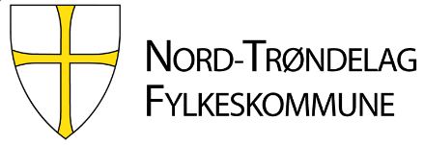
3.b. Assessment of Learning Outcomes

ERASMUS+ PROGRAM
KA106 LEARNERS AND STAFF MOBILITY
2020-2025

Trainee:
Subject and Qualification:
Company: _____________________________ Mentor:_______________________
Period: from: ______________to:_______________

Achievements related to goals from the Learning Agreement / Hard Skills | Sufficient (low) | Satisfactory (average) | Very satisfactory | Excellent | Not applicable
Communication in a foreign language, both orally and written
Work ethics
(Punctuality/accuracy)
Handle contact with customs
Participate in the processes of marketing, improvement of forms, guest reviews, statistics and planning
Prepare and conduct daily tasks in accordance with established routines
Other learning outcomes…
 | Sufficient (low) | Satisfactory (average) | Very satisfactory | Excellent | Not applicable
Informal learning outcomes/ Soft skills | Please give a textual opinion of the trainee.  (not subject to formal assessment)
Language/Communication skills

Cultural competence

Responsibility

Autonomy and Independency

Initiative/social skills

Punctuality/accuracy

Integration in company

Participation/ Interest/Initiative

Handle cultural awareness as a good host
Provide good service as guests expect
Global assessment/
Personal comments if wanted (Europass Mobility will give a more detailed description)

Date/Place:
Mentor’s signature Student's signature

