Information regarding your appointment for dental treatment under general anaesthetic at Røros sykehus

If you are unable to come to your scheduled appointment, please call us:
74176030 (Tone), between 08.00 – 15.00
Patients must be fasting - no food or drink in the last 6 hours.

If you are not fastning, there can be no treatment under general anaesthetic. Children with appointments for general anaesthetic after 10 AM, can drink 1-2 glasses of water in the morning, not less than 2 hours before the appointment (see following information)

Please know your weight on arrival. We also need a contact person’s telephone number.

«Travelling to appointments»

Public transport is the usual method of travel. If you have the right to a taxi or other form of transport because of special needs, you must acquire a voucher from your doctor or local social office before travelling.

Special transport can usually be booked at your dental clinic, the day before travelling.

The patient must have someone with them while awakening, and during the following night. That person must also arrange for transport home, your dental clinic order this the day before.

Best regards,
Line Paulsen
Dental nurse / coordinator

Dear patient

The anaesthetic department of St.Olav’s (Røros) are responsible for anaesthesia under your operation, and a nurse will look after you when you wake up. You can not drive after general anaesthetic, so you should have someone to look after you and arrange transport home.

Before the operation
Fasting
You must be fasting when you arrive for the appointment. Your stomach must be empty to avoid complications under the general anaesthetic. If you are not fasting, there may be no operation.

Fasting:
- Do not eat
- Do not drink
- Do not eat sweets
- Do not chew gum
- Do not smoke or use snuff
in the last 6 hours before your appointment

But

Young people and adults: Can drink water, clear juice, tea and coffee without milk up to 2 hours before the appointment. ( 2 glasses/cups)
Prescription medicines can be taken up to 2 hours before the appointment, with one glass of water.

Children 1 – 12 years: Can drink water and clear juice, 1 glass up to 2 hours before the appointment.

All children 1- 12 years should have an EMLA plaster placed over a visible vein on the back of the hand or in the elbow. The Emla plaster has to be placed 1 hour before the appointment. EMLA plasters can be bought at any pharmacy without prescription. Read the instructions that come with it.
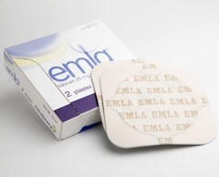
If the child does not accept a plaster, don’t worry, just try. The child will then be anaesthetised using a mask, while sitting on a parent’s lap. This is quite usual. Children who are frightened of injections can choose a mask instead of injection.
Pregnancy
If you become pregnant after the date is set for the operation, contact the hospital to see if the operation should be postponed.

Infections
If you have a cold, influenza, sore throat, ear infection, bronchitis, pneumonia or other infectious illnesses, contact the hospital and ask if the appointment should be postponed.
NB: Note the MRSA form at the end of this letter.
The patient should not have a cold or have mouth sores.

Makeup/ nail varnish/ jewellery/ piercing
When you arrive at the department, all makeup and nail varnish must have been removed. This is because observance of skin colour, especially lip colour and the colour under the nails of patients is important while under general anaesthetic.
Jewellery/piercing must have been removed because of the danger of infection.

IF YOU TAKE PRESCIPTION MEDICATION, PLEASE BRING IT WITH YOU
It’s important that the anaesthesiologist knows which medication you use, and which tablets you’ve taken on the morning of your operation.

Should prescription medication be taken just before the operation?

The general rule is that prescription medication should be taken as usual.

If you take blood thinning medication like MAREVAN (WARFARIN) or PLAVIX, contact the anaesthetic department, tel: 72575704 or 72576195

Albyl-E ( aspirin) can be taken as usual
Albyl, Dispril, Globoid (acetylsalicylic acid ), to prevent blood clots or heart attacks should be taken as usual, unless advised otherwise.
Plavix, Persantin, Ticlid, Asasantin (bloodplate-inhibitors): should normally be taken as usual.
Pradaxa (dabigatran), Xarelto (rivaroksaban) and Eliquis (apixaban): These blood thinners should not be taken in the last 48 hours before an operation.

Antihypertensive medication:
Captopril, Enalapril, Renitec, Ramipril, Triatec, Gopten (ACE inhibitors): Should not be taken on the day of the operation.
Cozaar, Losartan, Teveten, Diovan, Valsartan, Aprovel, Irbesartan, Amias, Atacand, Candesartan, Micardis, Olmetec (angiotensin II inhibitors): Should not be taken on the day of the operation.

Diabetic medication
If you have diabetes type 1 or 2, treated by insulin or tablets, you should not take your medication on the day of the operation either as injection or tablets.
Measure your blood sugar level before leaving for your appointment. If it’s low, you can drink a glass of sweet juice.
Diabetic patients who use insulin pumps, should not normally stop using them the evening before the operation.

Other frequently used medication
For example: BETA BLOKKERS,
Atenolol, Blocadren, Brevibloc, Carvedilol, Emconcor, Inderal, Kredex, Metoprolol, Metoxoc, Pranolol, Seloken, Selo-Zok, Sotacor, Tenormin, Trandate, Uniloc etc.

Treatment for: High blood pressure, angina pectoris, heart attack etc.
These medicaments shall be taken on the day of the operation.
If you normally take the medication in the evening – take it as usual.
If you are in doubt as to whether you take beta blockers, ask your own doctor.

Asthma medication: take the morning of the operation
Long-acting nitro-glycerin : take the morning of the operation
Sleeping tablets: can be taken the evening before the operation.
Antiepileptic medication: take as usual the morning of the operation.
Hypothyroid medication: can be taken the evening before the operation.

Medication taken on the day of the operation should be taken with ½ - 1 glass of water 1-2 hours before the appointment.

If there are significant changes in your health – please inform us as soon as possible.

Rinse your mouth with Corsodyl for 3 days before treatment (adults and children over 12 years of age )

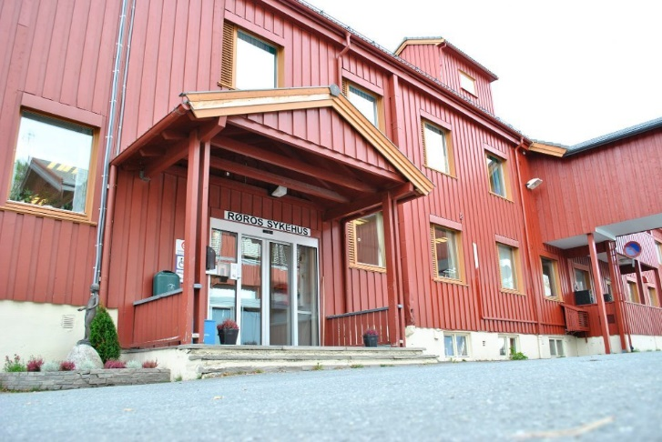

Velkommen!

To limit the spread of Coronavirus, we need answers to the following questions
One form for patient and one for eventual companion.
Name, date of birth, patient number:
Date and time:
1. Have you tested positive for the coronavirus (COVID-19)? Yes No
2. Are you in quarantine? Yes No
3. Are any of the people you live with in quarantine / isolation?
Yes No
4. Have you been traveling outside Norway in the last 14 days?
Yes No
5. Have you had any cold / flu symptoms in the last 7-14 days?
Yes No
6. Have you experienced a reduced sense of taste or smell in the last 7-14 days?
Yes No
7. Do you have asthma or allergies, if so, which ones?
Yes No
The patient is informed to contact the clinic by phone if any of the above points change before the appointment.
The patient is informed that the appointment can be canceled at short notice if necessary to take care of the infection prevention conciderations:
The patient is informed to contact the clinic if the patient or companion is diagnosed with COVID-19 within 48 hours after visiting the clinic:

MRSA and Tuberculosis
(Methicillin-resistant Staphylococcus aureus) MRSA is a bacteria responsible for infections that are difficult to treat with normal antibiotics.
If the answer is Yes to one of these questions below, contact your own doctor 2 weeks before your appointment.
Take this form to your doctor who will decide whether or not to take some tests.
If the answer is No to these questions, no more is required.
Have you had MRSA diagnosed before ? | Yes | No
Have you in the last 12 months before admission to hospital :
- Lived in the same house as someone diagnosed with MRSA ? | Yes | No
- Had close contact with anyone with MRSA? | Yes | No
- Been admitted to or have been to outpatients at a hospital / health centre/ dental clinic outside of Scandinavia ? | Yes | No
- Worked in the health care profession outside of Scandinavia ? | Yes | No
- Been to a children’s home or refugee camp outside of Scandinavia ? | Yes | No
- Had extensive skin lesions or skin infections, and been more than 6 weeks at a stretch outside of Scandinavia | Yes | No
- Had medical equipment piercing the skin or mucous membrane f.ex. bladder catheter, intravenous lines or similar, and been longer than 6 weeks at a stretch outside of Scandinavia ? | Yes | No
Tuberculosis investigation  Have you been at least 3 months in countries other than Western Europe, USA, Canada, Australia, New Zealand and Japan? | Yes | No
Have you been in contact with tuberculosis infection, or is there any other way you could be infected with tuberculosis ? | Yes | No

